Use the language and images for promotion on your website, social media page, newsletter or email.
First Aid for Mental Health – See the world through the eyes of others
First aid training for mental health for all United Methodist Church clergy and their spouses, Church leaders, staff and congregation members.
First Aid for Mental Health erases the stigma surrounding mental health and enforces the idea that it’s OK, not to be OK. It also teaches attendees how to accept their own mental health struggles without embarrassment or shame.
First Aid for Mental Health is for EVERYONE. The skills acquired can be applied to many situations, including home, social and professional environments.
Scan the QR code or visit the First Aid for Mental Health page at wespath.org/r/firstaidmh to learn more.
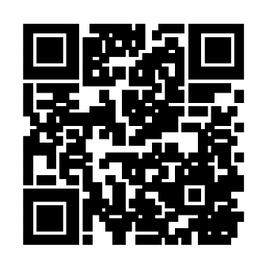
5811/012522

