Use the language and images to create an email or publish in a newsletter.
First Aid for Mental Health – See the world through the eyes of others
Live, virtual training – March 10 and 24
Recognizing the need to create a more empathic community and environment within the United Methodist Church for those struggling with mental health, Wespath is offering first aid training for mental health.
First Aid for Mental Health erases the stigma surrounding mental health and emphasizes that it’s OK, not to be OK. It also teaches attendees how to accept their own mental health struggles without embarrassment or shame. The training teaches how to:
- Identify when you or someone you know may be struggling with mental health
- Start a conversation with someone who is struggling
- Respond with empathy
- Help those who are struggling get the help they need
- Take action to manage your own mental health challenges
First Aid for Mental Health is for EVERYONE. Clergy and their spouses, Church leaders, staff and congregation members are all invited to attend—at no cost. The skills acquired can be applied to many situations, including home, social and professional environments.
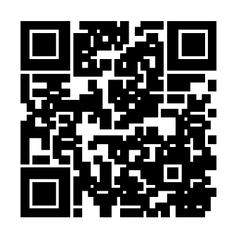
For more information and to register, scan the QR code or visit the First Aid for Mental Health event page at Wespath.org/r/firstaidmh.
5812/012522

