Topic: Join a webinar
Copy: 1 in 5 Americans experience mental illness each year. You can help! Wespath is offering two webinars where you can learn to identify and understand mental health challenges with empathy. For more information and to register, click here: wespath.org/r/firstaidmh #UMC
Resources (graphics):
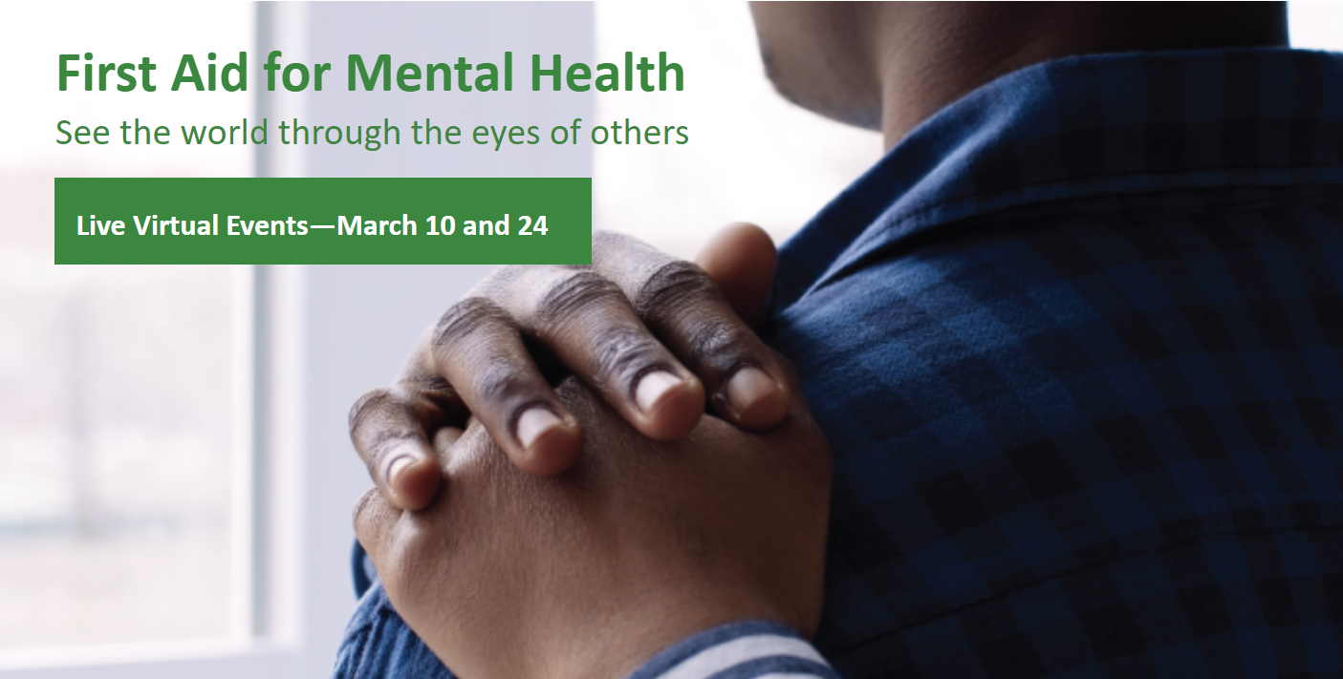

Topic: Join a webinar
Copy: We want to create a more empathic environment within the United Methodist Church for individuals struggling with mental health challenges—and you can help! To learn how, visit the First Aid for Mental Health event page at wespath.org/r/firstaidmh #UMC
Resources (graphics):
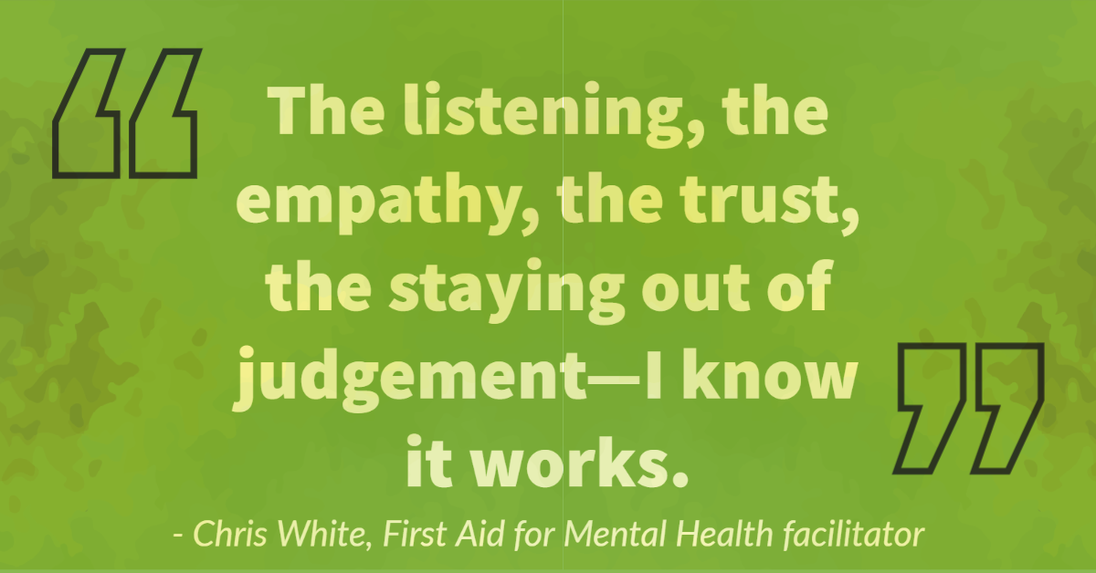

Topic: Join a webinar
Copy: You can help create a more empathic environment within the United Methodist Church for individuals struggling with mental health challenges. To learn how, visit the First Aid for Mental Health event page at wespath.org/r/firstaidmh #UMC
Resources (graphics):
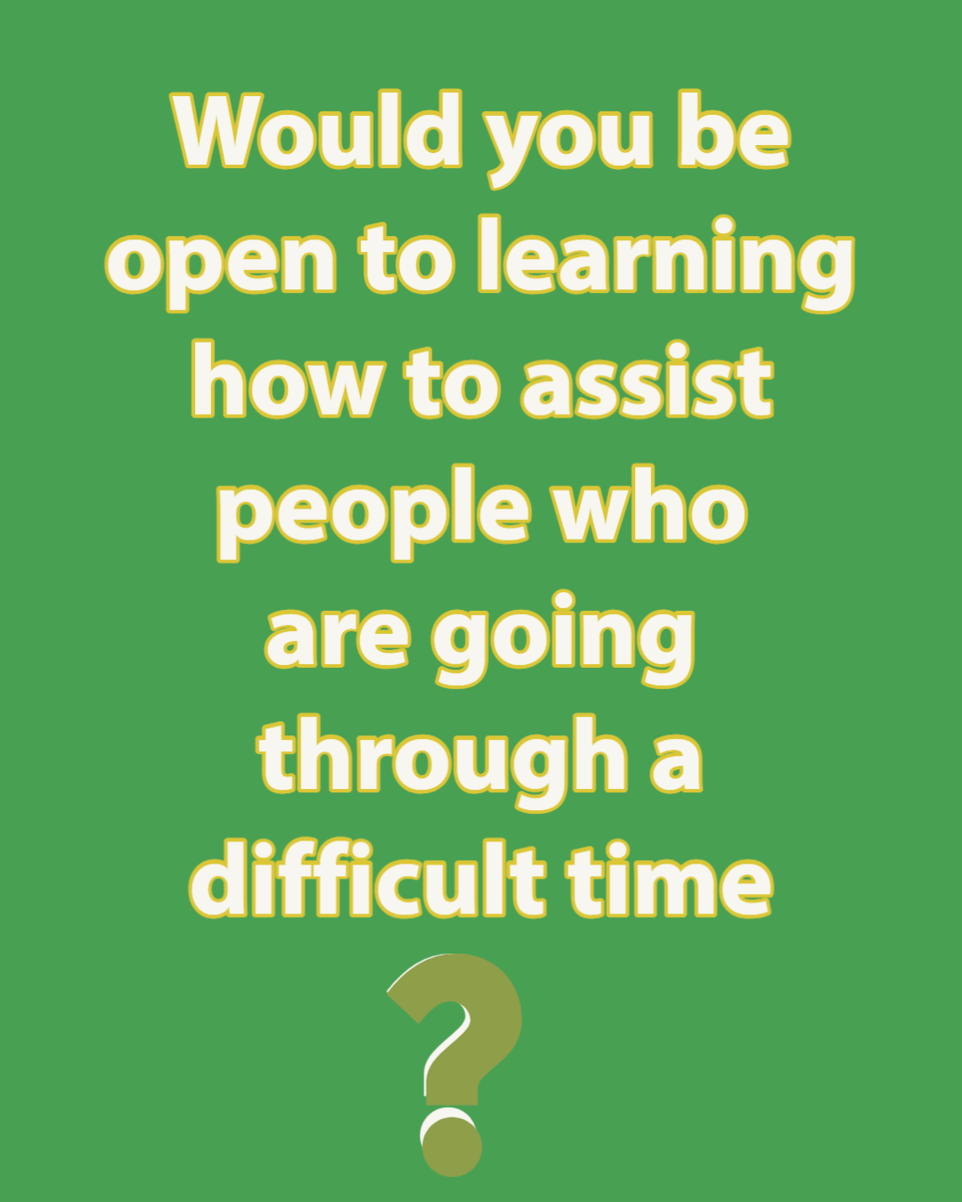

Topic: Encourage clergy to join a webinar
Copy: 1 in 3 #UMC clergy are experiencing issues with things like sleep and concentration because of depressive symptoms. You can help yourself and your peers! Wespath is offering webinars where you can learn to understand mental health challenges with empathy: wespath.org/r/firstaidmh
Resources (graphics):

